**CSC 581 ASSIGNMENT**

**Kali Linux VirtualBox with Introductory Linux Commands**

Kali Linux is a popular operating system used by security professionals and enthusiasts for various cybersecurity tasks such as penetration testing, digital forensics, and ethical hacking. In this lab, the objective was to set up a Kali Linux virtual machine (VM) and execute basic Linux commands to familiarize oneself with the Linux environment.

**Lab Setup:**

1.Installed VirtualBox from <https://www.virtualbox.org/>

2.Downloaded Kali Linux Image from <https://www.kali.org/get-kali/#kali-installer-images> :

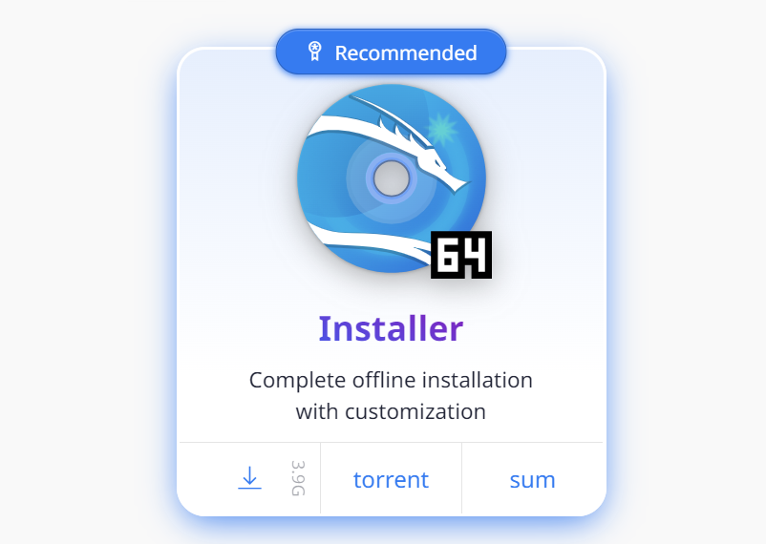

**Task 1: Creating a Kali Linux Virtual Machine (VM)**

Created a new Virtual Machine

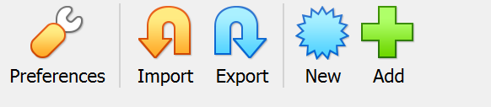

Created a kali linux Operating System(Type:Linux,Debian 64 bit) and uploaded the ISO Image

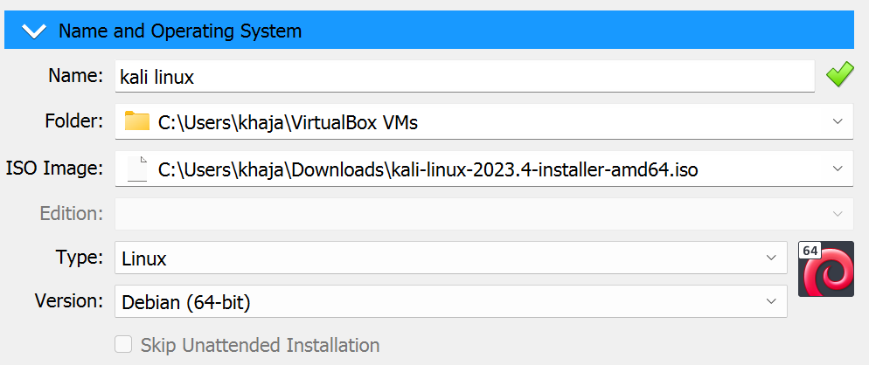

Setup Base Memory as **4096 MB**

Processors as **2 CPUs**

Setup Graphic Install

**Task 2: Initial Configuration and Login**

Configured hostname, skipped Domain name , setup Fullname and Password

Partitioning method :

**Guided-use entire disk**

**All files in one partition (recommended for new users)**

**Finish partitioning and write changes to disk**

Software Selection,choose everything except **GNOME,KDE Plasma**

Install the GRUB boot loader?(Select **Yes**)

Select your Device Disk for boot loader installation

**Task 3: Introduction to Linux Terminal**

1. Open the Linux terminal within your Kali Linux VM.
2. Executed the following introductory Linux commands :

-pwd (Print Working Directory): Used to display the current directory.

- ls (List Directory Contents): Used to list files and directories in the current directory.

- cd (Change Directory): Used to navigate between directories.

- mkdir (Make Directory):Created a new directory.

- touch: Created a new empty file.

- vim (Vi Improved):A text editor used to create and modify files.

- cat (Concatenate and Display Files):Used to display the contents of a file.

**Task 4: Basic File Operations**

1. Created a new directory named "LabFOlder” using mkdir command.
2. Navigated to the "LabFOlder" directory using the ‘cd’ command.
3. Create a text file named "hello.txt" using the ‘touch’ command.
4. Used ‘vim’ command to open that text file
5. Used key ‘i’ to insert content into the text file
6. Press ‘esc’ to escape and ‘:wq’ to save the contents of the file

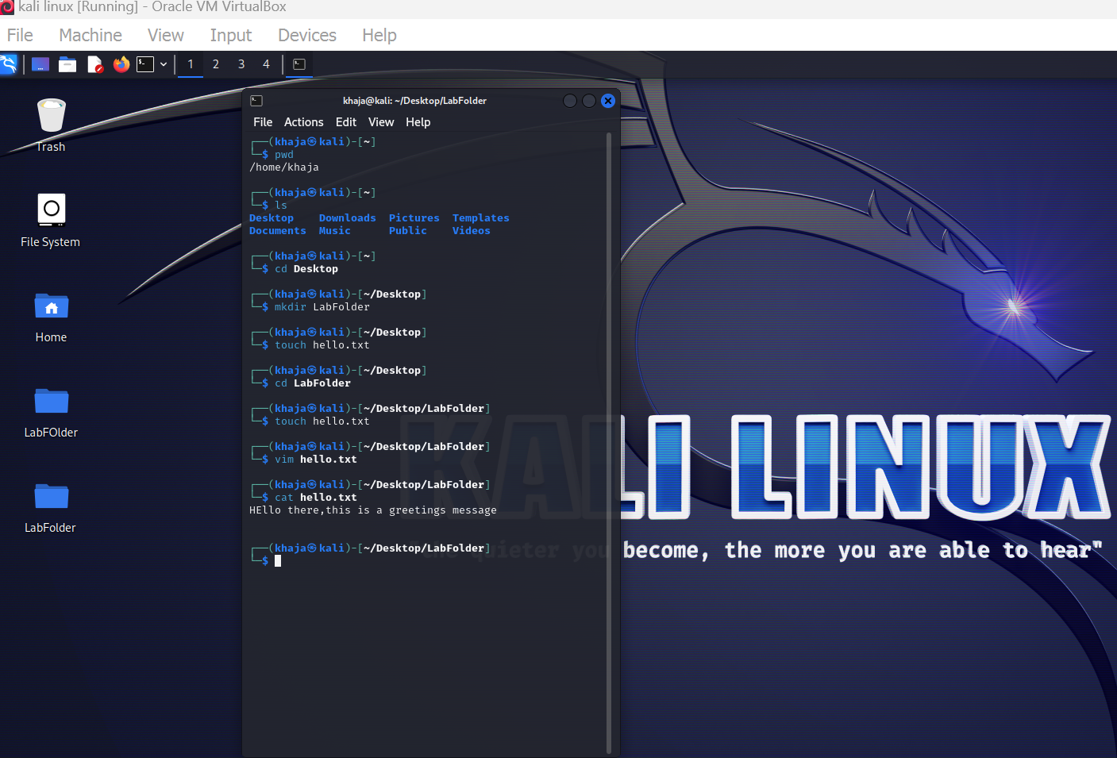

**Reflection on using Kali Linux:**

1. Familiarization with Command Line Interface (CLI):

- Through executing commands like `pwd`, `ls`, and `cd`, I gained familiarity with navigating the directory structure within the terminal environment. This was crucial for efficient interaction with the operating system.

2. File Manipulation:

- Utilizing commands such as `mkdir`, `touch`, and `cat` allowed me to create directories, generate files, and manipulate file contents. Understanding these commands is fundamental for file management tasks.

3. Text Editing with Vim:

- Vim proved to be a powerful text editor, although its learning curve can be steep for beginners. However, basic functionalities like creating, editing, and saving files were achieved through practice.

Conclusion:

Exploring Kali Linux and executing basic Linux commands provided a foundational understanding of operating within a Linux environment. Familiarity with these commands is essential for anyone working in cybersecurity or any field requiring proficiency in Linux systems. This lab served as an introductory step towards gaining proficiency in using Kali Linux and understanding its capabilities for various security-related tasks.